Experiment 1: Write a C program to calculate the roots of the quadratic equation ax²+bx+c = 0 where a, b and c are known using if-else-if ladder.

Objective:
To write a C program to calculate the roots of a quadratic equation ax² + bx +c= 0 using the if-else-if ladder.
Problem analysis: To find the roots of a quadratic equation of the form ax² + bx + c = 0, we first need to identify the input values: the coefficients a, b, and c. Based on these inputs, we calculate the discriminant (D = b² - 4ac), which helps determine the nature of the roots:
- If D > 0, the equation has two distinct real roots.
- If D == 0, the equation has two equal real roots.
- If D < 0, the roots are complex (imaginary).
By using an if-else-if ladder, the program checks each condition of the discriminant and calculates the roots accordingly using the quadratic formula. The program then outputs the calculated roots in appropriate form.
Input variable | Processing variable | Output variable | Header file
a,b,c(float) | D=b²-4ac | roots of the equation(real/ complex) | <stdio.h>  <math.h>

Algorithm:
Step1-start
Step2- input values of a,b,c
Step3- calculate discriminant: D=b²-4ac
Step4- If D > 0 → real & different roots
Step5- If D == 0 → real & equal roots
Step6- If D < 0 → complex roots
Step7- Display the roots
Step8- End
Flowchart:

D==0

D > 0

Yes

Yes

No

No

Start

Input a , b , c

Calculate D = b²-4ac

Print real &
distinct roots

Print Complex
roots

Print equal
real roots

Display
roots

End

Source code:
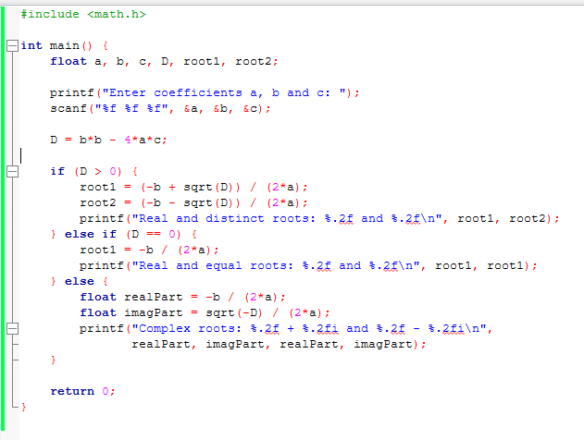
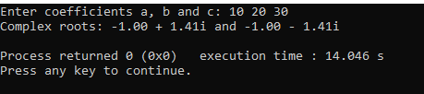
Discussion & Conclusion:
This program uses the if-else-if ladder to distinguish between the three possible nature of roots based on the discriminant. It uses the (math.h) library to compute square roots. Special care is taken to compute and display complex roots correctly. It handles all valid cases for any values of a, b, and c except when a = 0, which should be a separate linear case (bx + c = 0). Finally, this program successfully computes and displays the nature and values of the roots of a quadratic equation based on the discriminant. It demonstrates the use of conditional branching (if-else-if) and mathematical operations in C for real and complex numbers.
Experiment-02 : Write a C program to find out wheather a character is Vowel or Consonant using Switch statement.
Objective:
- To check whether a given character is a vowel or consonant using the switch statement.

Problem Analysis:
A vowel is one of the characters: a, e, i, o, u (and their uppercase counterparts). Any other alphabetic character is a consonant. The program should:
- Take a character as input.
- Use a switch statement to check for vowels.
- If not a vowel, and if the character is an alphabet, then it's a consonant.
If the input is not an alphabet, display an appropriate message.
Input variable | Processing variable | Output variable | Header file
ch (char) | Switch case for vowels default → consonant | Message: Vowel or Consonant | <stdio.h>  <ctype.h>

Algorithm:
Step1: start
Step2: Read a character ch
Step3: Convert to lowercase (optional)
Step4: Use switch to match a, e, I, o, u
Step5: If matched display vowel
Step6: Else → consonant
Step7: Display message
Step8: End
Flowchart: 

if is alpha(ch) == true

Switch(ch)

Yes

Yes

No

No

Start

Cases:

a, e,
I

, o, u,

A, E, I, O, U

Read character 'ch'

Print

"Vowel"

Print "Consonant"

Print "Not alphabet"

End

Source code:
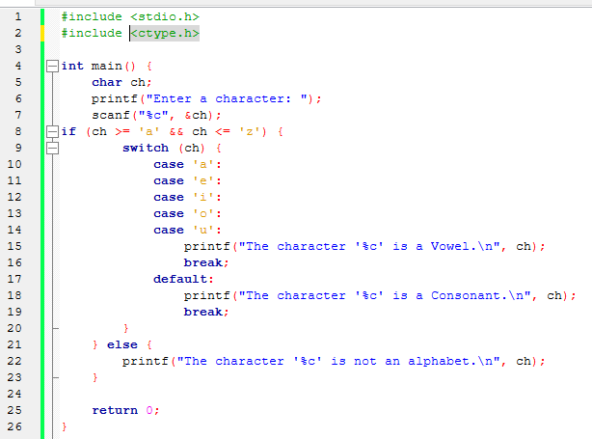
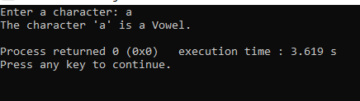
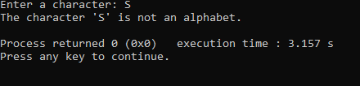
Discussion & Conclusion:
The program uses a switch statement for vowel detection. It checks for both lowercase and uppercase vowels. If a character doesn’t match any case, it falls into default. In default, is alpha() from <ctype.h> checks if the input is a letter. This prevents digits and special characters from being incorrectly identified. So , The program correctly identifies whether a character is a vowel, consonant, or not an alphabet using a switch statement. It is efficient, user-friendly, and demonstrates proper control flow and validation using C programming basics.

